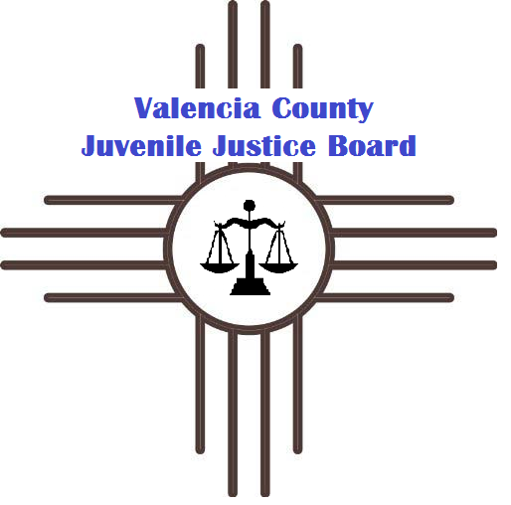
Valencia County Juvenile Justice Executive Board Meeting

Henry Perea Building
750 Morris Road, Los Lunas, NM 87031
August 25th, 2016 at 11:30 am
Executive Meeting Agenda

Executive Board Members: Ruben Barreras, Estevan Gallegos, Diana Good, Jeff Gordon, Catherine Harris, Judge Cindy Mercer, Tom Mraz, Father Mundy, Cruz Munoz, Bart Regelbrugge, Dr. Claire Smith, Lisa Storey

-Vote to approve agenda
-Approve BAR for New Day and Boys & Girls Club
-September Retreat
-Other business as time allows

Note: The Valencia County Juvenile Justice Board is an open meeting. Any person who wishes to attend this meeting, may do so. However, non-executive board members may not speak during the meeting unless asked to do so by an executive board member.

